2nd Grade Art Projects
October: Pissarro 1st Person Perspective
(this lesson can also be done in the spring, using tulips instead of pumpkins, if this project needs to be moved to a different month)
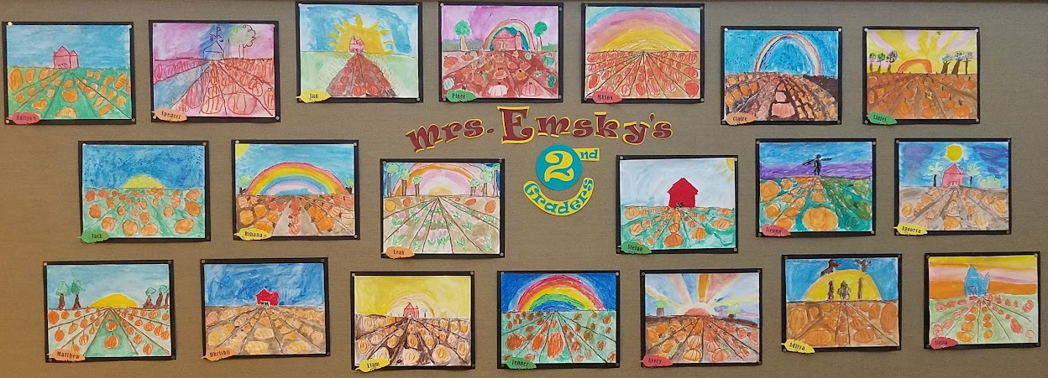

November: Print Making
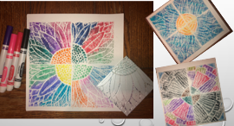

December: Kirchner Presentation birch tree
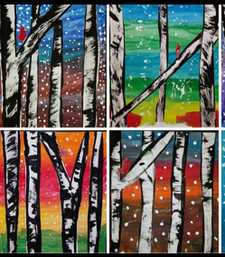

January: Picasso Cubist Portrait of Teacher
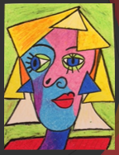
February: Hanging Clay Owls
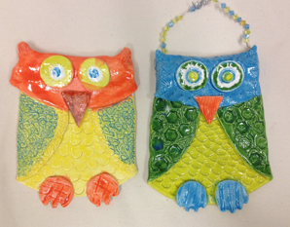

March: Positive Negative Space
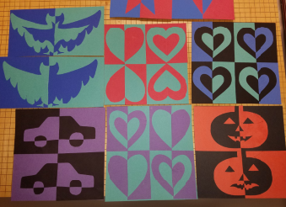
April: Rodrigue Blue Dog

May:

Additional Art Projects:
Remington Cactus
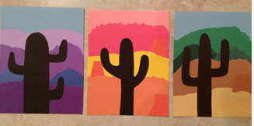

I have Something to Say
